**Exploratory Data Analysis**

1. We are Using the data from Canadian Institute for Cybersecurity (CIC) project funded by Canadian Internet Registration Authority (CIRA) data set <https://www.unb.ca/cic/datasets/dohbrw-2020.html>
2. It has 4 different data set DoH, Non-DoH, malicious DoH, Bengine so we merged those data set using program

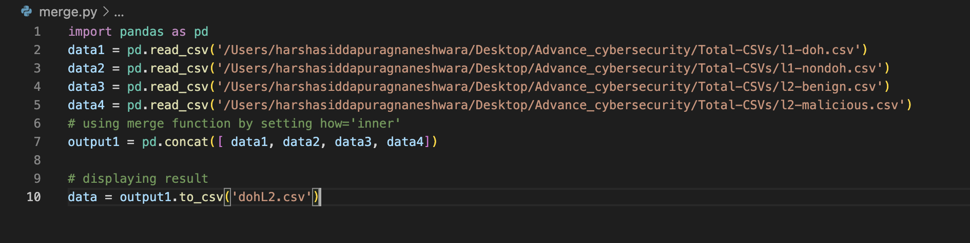

1. Importing data

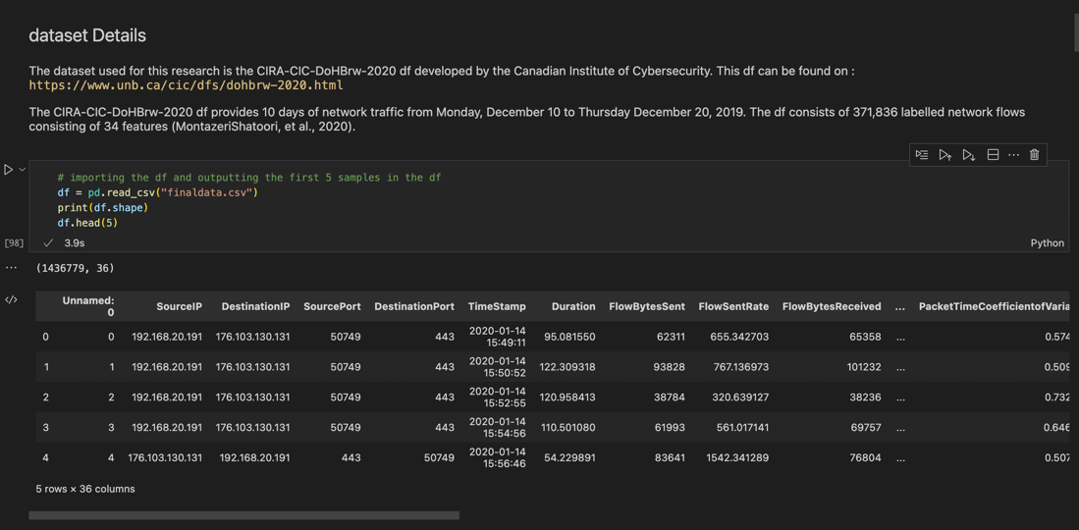

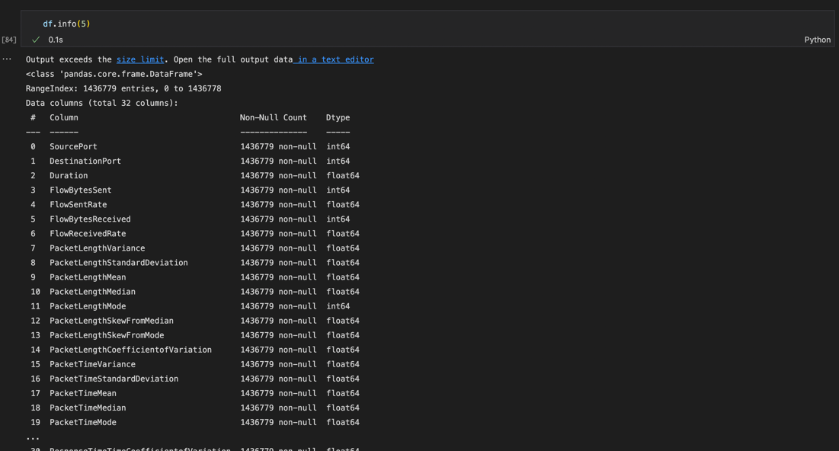

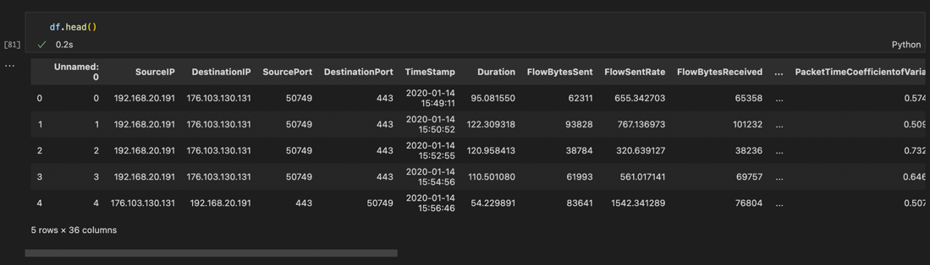

1. Checking for null values and dropping them.

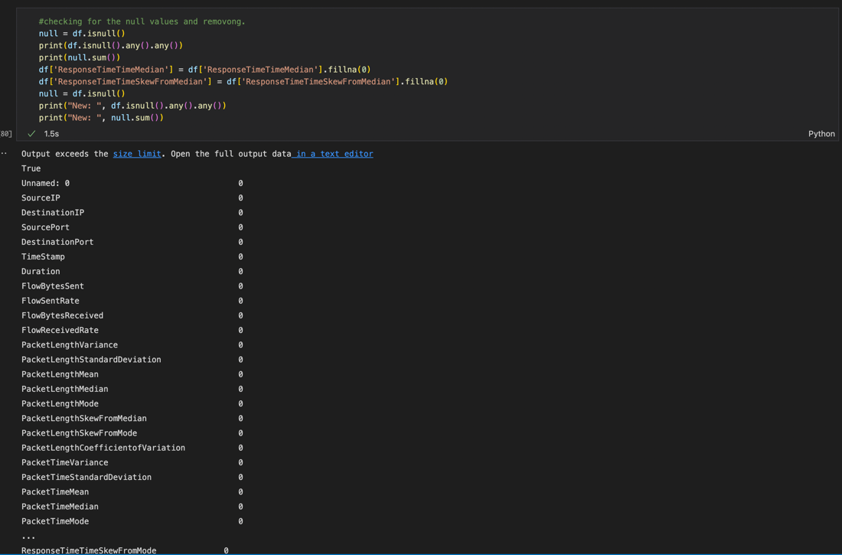

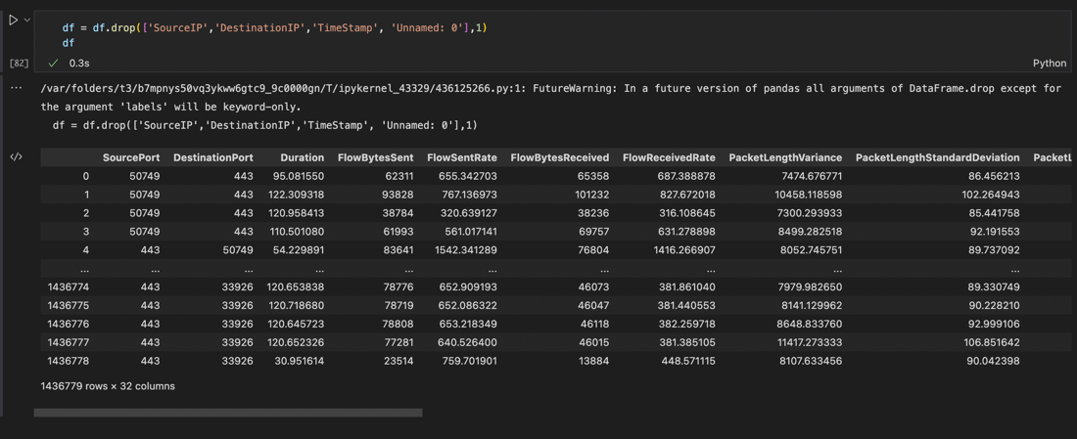

1. Classification of target column

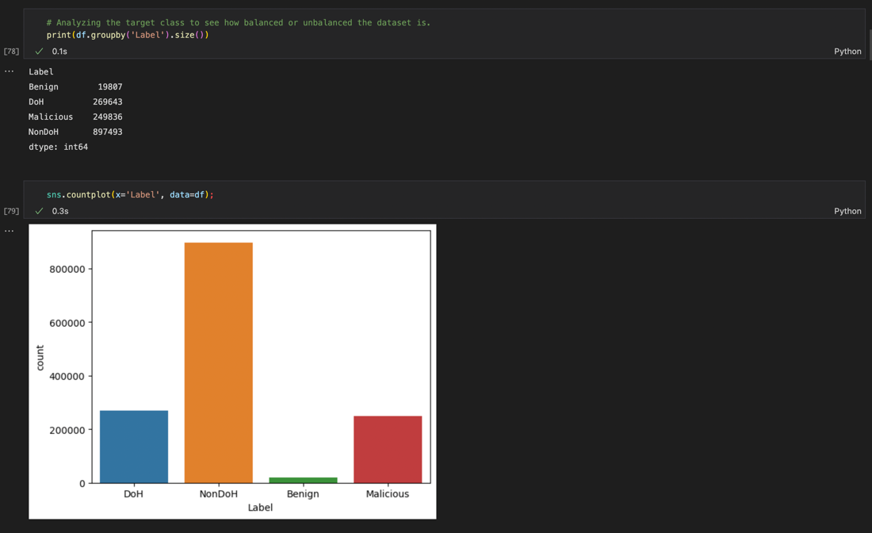

1. Co-relation

Co-relation between the DoH and features

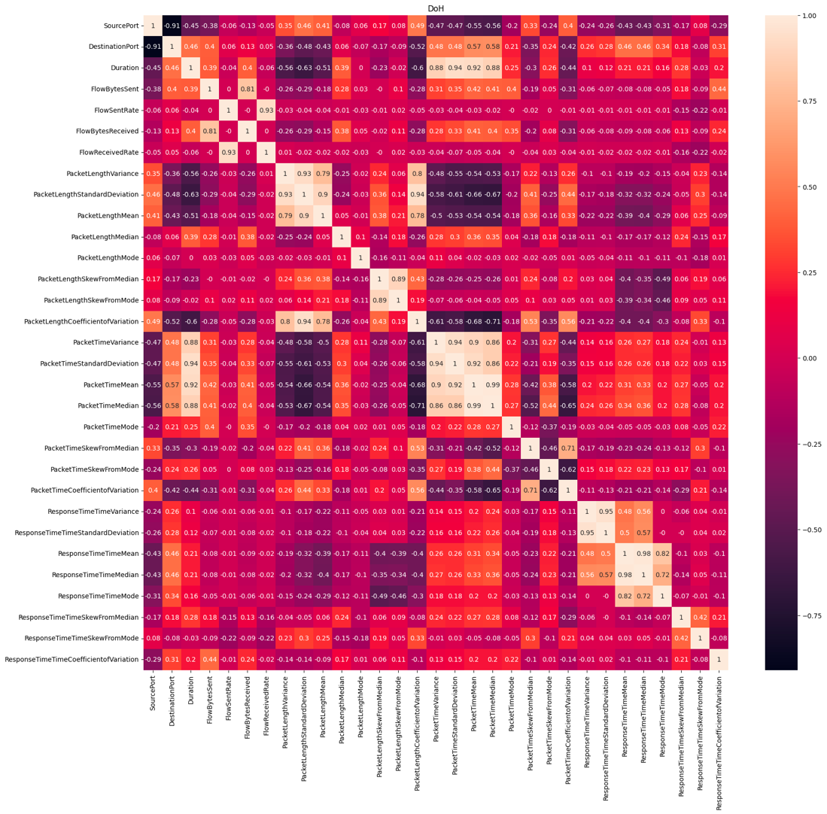

1. Data training

